EXPERIMENT 12:
PROGRAM CODE:

# ==============================================================
# CROSS-PLATFORM EDGE AI DEPLOYMENT
# PyTorch vs ONNX Runtime + TorchScript mobile artifact
# ==============================================================

!pip -q install onnx onnxruntime

import os
import time
import copy
import numpy as np
import pandas as pd
import matplotlib.pyplot as plt
import torch
import torch.nn as nn
import onnx
import onnxruntime as ort

from sklearn.datasets import load_digits
from sklearn.model_selection import train_test_split
from sklearn.preprocessing import StandardScaler
from sklearn.metrics import accuracy_score
from IPython.display import display

np.random.seed(24)
torch.manual_seed(24)
torch.set_num_threads(1)

OUT = "/content/edge_ai_project"
os.makedirs(OUT, exist_ok=True)

print("=" * 75)
print("CROSS-PLATFORM EDGE AI MODEL DEPLOYMENT")
print("PyTorch vs ONNX Runtime vs TorchScript")
print("=" * 75)

# --------------------------------------------------------------
# 1. LOAD DATASET
# --------------------------------------------------------------
print("\n1. DATASET LOADING")

# Handwritten digit dataset: 8x8 images, 10 classes
digits = load_digits()
X = digits.data.astype(np.float32)
y = digits.target.astype(np.int64)

X_train, X_test, y_train, y_test = train_test_split(
X, y, test_size=0.25, random_state=24, stratify=y
)

# Normalize features using training data only
scaler = StandardScaler()
X_train = scaler.fit_transform(X_train).astype(np.float32)
X_test = scaler.transform(X_test).astype(np.float32)

print("Training samples:", len(X_train))
print("Testing samples:", len(X_test))
print("Input features:", X_train.shape[1])
print("Classes:", len(np.unique(y)))

# --------------------------------------------------------------
# 2. DEFINE AND TRAIN PYTORCH MODEL
# --------------------------------------------------------------
print("\n" + "=" * 75)
print("2. PYTORCH MODEL TRAINING")
print("=" * 75)

class EdgeClassifier(nn.Module):
def __init__(self):
super().__init__()
self.network = nn.Sequential(
nn.Linear(64, 64),
nn.ReLU(),
nn.Linear(64, 32),
nn.ReLU(),
nn.Linear(32, 10)
)

def forward(self, x):
return self.network(x)

model = EdgeClassifier()
optimizer = torch.optim.Adam(model.parameters(), lr=0.01)
criterion = nn.CrossEntropyLoss()

Xtr = torch.from_numpy(X_train)
ytr = torch.from_numpy(y_train)

start_train = time.perf_counter()

for epoch in range(100):
model.train()
optimizer.zero_grad()
logits = model(Xtr)
loss = criterion(logits, ytr)
loss.backward()
optimizer.step()

training_time = time.perf_counter() - start_train
model.eval()

print("Training completed successfully.")
print("Final training loss:", round(loss.item(), 4))
print("Training time (s):", round(training_time, 3))

# --------------------------------------------------------------
# 3. SAVE PYTORCH MODEL
# --------------------------------------------------------------
pytorch_path = os.path.join(OUT, "edge_model.pth")
torch.save(model.state_dict(), pytorch_path)
print("\nPyTorch model saved:", pytorch_path)

# --------------------------------------------------------------
# 4. EXPORT TO ONNX
# --------------------------------------------------------------
print("\n" + "=" * 75)
print("3. CONVERTING PYTORCH MODEL TO ONNX")
print("=" * 75)

onnx_path = os.path.join(OUT, "edge_model.onnx")
example_input = torch.randn(1, 64)

# Legacy exporter is used here for broad compatibility with Colab.
torch.onnx.export(
model,
example_input,
onnx_path,
input_names=["input"],
output_names=["logits"],
dynamic_axes={
"input": {0: "batch_size"},
"logits": {0: "batch_size"}
},
opset_version=17,
dynamo=False
)

onnx_model = onnx.load(onnx_path)
onnx.checker.check_model(onnx_model)

print("ONNX conversion successful.")
print("ONNX model validation successful.")
print("ONNX model saved:", onnx_path)

# --------------------------------------------------------------
# 5. CREATE TORCHSCRIPT MOBILE-DEPLOYMENT ARTIFACT
# --------------------------------------------------------------
print("\n" + "=" * 75)
print("4. CREATING TORCHSCRIPT ARTIFACT")
print("=" * 75)

scripted_model = torch.jit.trace(model, example_input)
scripted_model = torch.jit.freeze(scripted_model)

torchscript_path = os.path.join(OUT, "edge_model_torchscript.pt")
torch.jit.save(scripted_model, torchscript_path)

loaded_scripted_model = torch.jit.load(torchscript_path)
loaded_scripted_model.eval()

print("TorchScript export successful.")
print("TorchScript artifact saved:", torchscript_path)
print("This is an export artifact; Android deployment still requires")
print("an application/runtime integration.")

# --------------------------------------------------------------
# 6. RUN INFERENCE ON ALL THREE RUNTIMES
# --------------------------------------------------------------
print("\n" + "=" * 75)
print("5. CROSS-PLATFORM INFERENCE")
print("=" * 75)

# Use CPU consistently for a fair runtime comparison.
model_cpu = copy.deepcopy(model).cpu().eval()
scripted_cpu = torch.jit.load(torchscript_path, map_location="cpu").eval()

session = ort.InferenceSession(
onnx_path,
providers=["CPUExecutionProvider"]
)

X_tensor = torch.from_numpy(X_test)
input_name = session.get_inputs()[0].name

# Warm-up runs excluded from latency measurement.
with torch.inference_mode():
for _ in range(10):
model_cpu(X_tensor[:32])
scripted_cpu(X_tensor[:32])

for _ in range(5):
session.run(None, {input_name: X_test[:32]})

# PyTorch inference
start = time.perf_counter()
with torch.inference_mode():
pytorch_logits = model_cpu(X_tensor).numpy()
pytorch_total = time.perf_counter() - start

# ONNX Runtime inference
start = time.perf_counter()
onnx_logits = session.run(None, {input_name: X_test})[0]
onnx_total = time.perf_counter() - start

# TorchScript inference
start = time.perf_counter()
with torch.inference_mode():
torchscript_logits = scripted_cpu(X_tensor).numpy()
torchscript_total = time.perf_counter() - start

pred_pytorch = pytorch_logits.argmax(axis=1)
pred_onnx = onnx_logits.argmax(axis=1)
pred_torchscript = torchscript_logits.argmax(axis=1)

# --------------------------------------------------------------
# 7. ACCURACY AND NUMERICAL AGREEMENT
# --------------------------------------------------------------
print("\n" + "=" * 75)
print("6. ACCURACY AND PREDICTION VALIDATION")
print("=" * 75)

acc_pytorch = accuracy_score(y_test, pred_pytorch) * 100
acc_onnx = accuracy_score(y_test, pred_onnx) * 100
acc_torchscript = accuracy_score(y_test, pred_torchscript) * 100

print("PyTorch accuracy:", round(acc_pytorch, 2), "%")
print("ONNX Runtime accuracy:", round(acc_onnx, 2), "%")
print("TorchScript accuracy:", round(acc_torchscript, 2), "%")

print("PyTorch vs ONNX predictions identical:",
bool(np.array_equal(pred_pytorch, pred_onnx)))
print("PyTorch vs TorchScript predictions identical:",
bool(np.array_equal(pred_pytorch, pred_torchscript)))

# --------------------------------------------------------------
# 8. LATENCY AND THROUGHPUT BENCHMARK
# --------------------------------------------------------------
print("\n" + "=" * 75)
print("7. INFERENCE LATENCY AND THROUGHPUT")
print("=" * 75)

# Measure repeated single-sample inference latency after warm-up.
REPEATS = 300
sample = X_test[:1]
sample_tensor = torch.from_numpy(sample)

# PyTorch latency
pytorch_times = []
with torch.inference_mode():
for _ in range(REPEATS):
t0 = time.perf_counter()
model_cpu(sample_tensor)
pytorch_times.append(time.perf_counter() - t0)

# ONNX Runtime latency
onnx_times = []
for _ in range(REPEATS):
t0 = time.perf_counter()
session.run(None, {input_name: sample})
onnx_times.append(time.perf_counter() - t0)

# TorchScript latency
torchscript_times = []
with torch.inference_mode():
for _ in range(REPEATS):
t0 = time.perf_counter()
scripted_cpu(sample_tensor)
torchscript_times.append(time.perf_counter() - t0)

pytorch_latency = np.median(pytorch_times) * 1000
onnx_latency = np.median(onnx_times) * 1000
torchscript_latency = np.median(torchscript_times) * 1000

# Effective throughput from full-test-set execution
pytorch_throughput = len(X_test) / max(pytorch_total, 1e-9)
onnx_throughput = len(X_test) / max(onnx_total, 1e-9)
torchscript_throughput = len(X_test) / max(torchscript_total, 1e-9)

# --------------------------------------------------------------
# 9. MODEL SIZE COMPARISON
# --------------------------------------------------------------
def size_mb(path):
return os.path.getsize(path) / (1024 * 1024)

results = pd.DataFrame({
"Runtime / Artifact": [
"PyTorch",
"ONNX Runtime",
"TorchScript"
],
"Accuracy (%)": [
acc_pytorch, acc_onnx, acc_torchscript
],
"Median Single-Sample Latency (ms)": [
pytorch_latency, onnx_latency, torchscript_latency
],
"Test-Set Throughput (samples/s)": [
pytorch_throughput, onnx_throughput, torchscript_throughput
],
"Model File Size (MB)": [
size_mb(pytorch_path),
size_mb(onnx_path),
size_mb(torchscript_path)
]
})

print("\n" + "=" * 75)
print("8. FINAL PERFORMANCE COMPARISON")
print("=" * 75)
display(results.round(4))

results.to_csv(os.path.join(OUT, "performance_comparison.csv"), index=False)

# --------------------------------------------------------------
# 10. PERFORMANCE GRAPHS
# --------------------------------------------------------------
plot_metrics = [
("Accuracy (%)", "Model Accuracy Comparison", "Accuracy (%)"),
("Median Single-Sample Latency (ms)",
"Inference Latency Comparison", "Latency (ms)"),
("Test-Set Throughput (samples/s)",
"Inference Throughput Comparison", "Samples per second"),
("Model File Size (MB)", "Model File Size Comparison", "Size (MB)")
]

for column, title, ylabel in plot_metrics:
plt.figure(figsize=(8, 4.5))
plt.bar(results["Runtime / Artifact"], results[column])
plt.title(title)
plt.ylabel(ylabel)
plt.xlabel("Runtime / Artifact")
plt.grid(axis="y", alpha=0.3)
plt.xticks(rotation=12, ha="right")
plt.tight_layout()
plt.show()

# --------------------------------------------------------------
# 11. SAMPLE INFERENCE OUTPUT
# --------------------------------------------------------------
print("\n" + "=" * 75)
print("9. SAMPLE INFERENCE RESULTS")
print("=" * 75)

sample_results = pd.DataFrame({
"Actual Digit": y_test[:15],
"PyTorch Prediction": pred_pytorch[:15],
"ONNX Prediction": pred_onnx[:15],
"TorchScript Prediction": pred_torchscript[:15]
})
display(sample_results)

# --------------------------------------------------------------
# 12. PACKAGE ALL OUTPUT FILES
# --------------------------------------------------------------
import zipfile

zip_path = "/content/edge_ai_deployment_results.zip"

with zipfile.ZipFile(zip_path, "w", zipfile.ZIP_DEFLATED) as z:
for filename in os.listdir(OUT):
z.write(
os.path.join(OUT, filename),
arcname=filename
)

print("\n" + "=" * 75)
print("10. PROJECT CONCLUSION")
print("=" * 75)
print("1. A real digit-classification model was trained.")
print("2. The model was exported to ONNX and TorchScript formats.")
print("3. Inference results were compared across runtimes.")
print("4. Accuracy, latency, throughput and model size were measured.")
print("5. Comparison graphs and CSV results were generated.")
print("\nNOTE:")
print("Measurements are from this Colab CPU environment.")
print("TorchScript is an exported artifact, not a benchmark on a phone.")
print("For real mobile benchmarking, run the model on Android hardware.")
print("\nDownload package:", zip_path)

from google.colab import files
files.download(zip_path)

OUTPUT:
===========================================================================
CROSS-PLATFORM EDGE AI MODEL DEPLOYMENT
PyTorch vs ONNX Runtime vs TorchScript
===========================================================================

1. DATASET LOADING
Training samples: 1347
Testing samples: 450
Input features: 64
Classes: 10

===========================================================================
2. PYTORCH MODEL TRAINING
===========================================================================
Training completed successfully.
Final training loss: 0.0005
Training time (s): 0.651

PyTorch model saved: /content/edge_ai_project/edge_model.pth

===========================================================================
3. CONVERTING PYTORCH MODEL TO ONNX
===========================================================================
/tmp/ipykernel_7570/3319857009.py:124: DeprecationWarning: You are using the legacy TorchScript-based ONNX export. Starting in PyTorch 2.9, the new torch.export-based ONNX exporter has become the default. Learn more about the new export logic: https://docs.pytorch.org/docs/stable/onnx_export.html. For exporting control flow: https://pytorch.org/tutorials/beginner/onnx/export_control_flow_model_to_onnx_tutorial.html
torch.onnx.export(
ONNX conversion successful.
ONNX model validation successful.
ONNX model saved: /content/edge_ai_project/edge_model.onnx

===========================================================================
4. CREATING TORCHSCRIPT ARTIFACT
===========================================================================
TorchScript export successful.
TorchScript artifact saved: /content/edge_ai_project/edge_model_torchscript.pt
This is an export artifact; Android deployment still requires
an application/runtime integration.

===========================================================================
5. CROSS-PLATFORM INFERENCE
===========================================================================

===========================================================================
6. ACCURACY AND PREDICTION VALIDATION
===========================================================================
PyTorch accuracy: 97.33 %
ONNX Runtime accuracy: 97.33 %
TorchScript accuracy: 97.33 %
PyTorch vs ONNX predictions identical: True
PyTorch vs TorchScript predictions identical: True

===========================================================================
7. INFERENCE LATENCY AND THROUGHPUT
===========================================================================

===========================================================================
8. FINAL PERFORMANCE COMPARISON
===========================================================================
 | Runtime / Artifact | Accuracy (%) | Median Single-Sample Latency (ms) | Test-Set Throughput (samples/s) | Model File Size (MB)
0 | PyTorch | 97.3333 | 0.0706 | 431999.4471 | 0.0280
1 | ONNX Runtime | 97.3333 | 0.0199 | 695632.8166 | 0.0260
2 | TorchScript | 97.3333 | 0.0411 | 308347.1634 | 0.0294
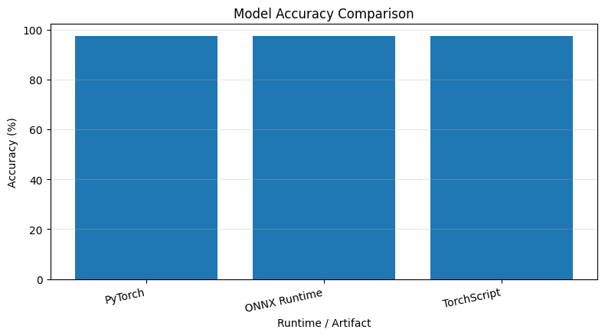
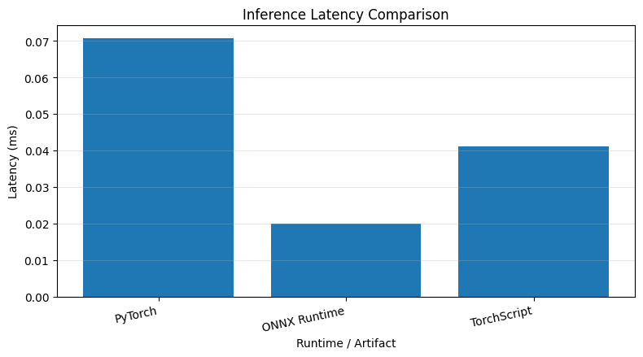
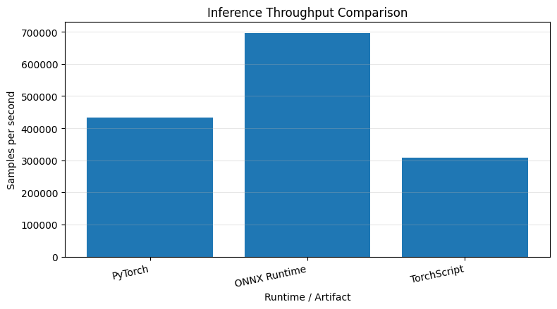
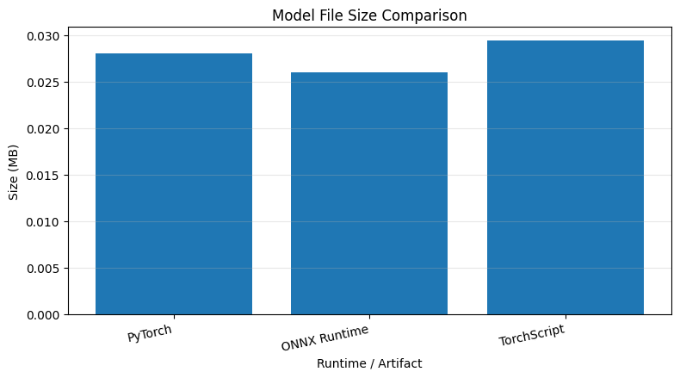

10. PROJECT CONCLUSION
===========================================================================
1. A real digit-classification model was trained.
2. The model was exported to ONNX and TorchScript formats.
3. Inference results were compared across runtimes.
4. Accuracy, latency, throughput and model size were measured.
5. Comparison graphs and CSV result

